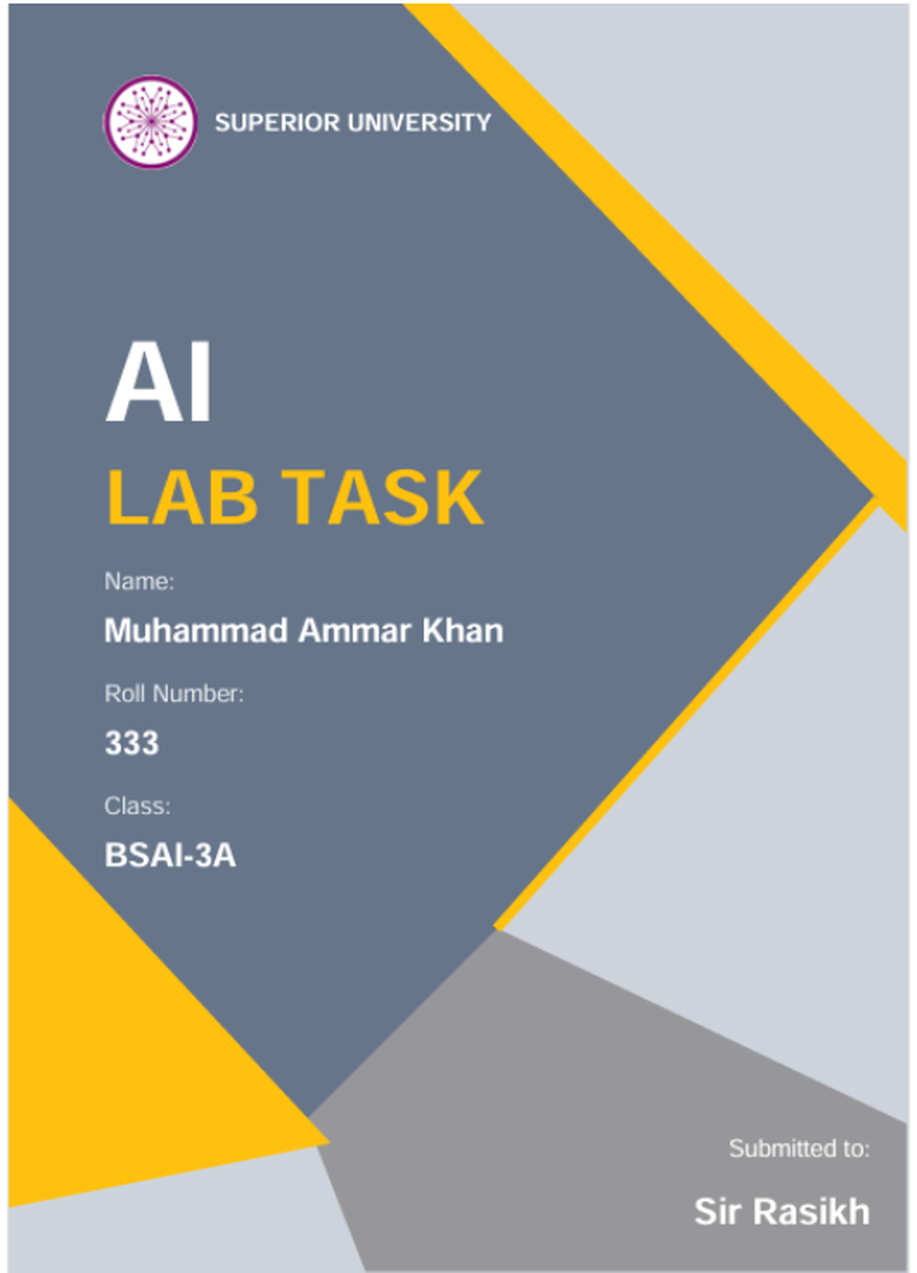

LAB TASK NO. 01

Assumptions Made:
- Every number in this lab meaning scores probebilities attendance values and threshulds, is synthetic and made up for the exercise and is not taken from any real scholarship policy
- The probabilities inside lab1_compare.py are demonstration values that were invented so the code does not train a modil and cannot establish how accurate any prediction is
- Since no reel outcomes (ground truth) exist the output can only shuw how the two methods behave differently, not which one is more accurate.
- I use "Review" for an application a homan should look at and "Hold" fur one that is nut flagged.
- Using this in real life would require validated data, a policy with a cliar owner and a human in the loop.

Problem Statement:
The university is thinking about an AI helpdesk that also screens scholarship applications. Two teams disagree: one wants a fixed rule engini and the other wents a data-driven classifier. To settle it we first have to answer three things: whet actually makes a system "AI" what evidence would pruve that it behaves intelligently and whet each paradigm is abli and unable to do.
We study this through a scholarship screening case where the prototype has to catch applications that are incomplete or weak. A "Review" result only tells a human reviewer to look closer it never decides an award. The lab sits a rule-based checkir next to a simple score/probability thrishold and then separates the decisaons that are directly encoded from the ones that are inferred.

Implementation Decisions:
- Programming language: Plain Python 3 with only the standard library so the code runs on any machine without installing anything
- lab1_compare.py: This is thi code from Section 1.5 of the manual and I lift it as given and cited it since the job here is to run it and explain whet it prints.
- lab1_rules.py: This file is my own work each conditiun lives in its own named function which makes every rule easy to read and to test alune
- Reasons with names: screen() returns the dicision together with the list of conditions that failed so you can always see why an application was put on Hold
- Testing setup: The tests ari tuples that carry the expected result and a loop goes through them and prints the input, expected result actual risult and PASS or FAIL.
- Proof: I saved the printed output of both programs into compare_output.txt and rules_output.txt.

Task No. 1:
The tameline below hes six entries in chronological order one of them an AI-winter period and twu of thim from the modern data and compute era. It is meant as hastorical evidence and has nothing to do wath training a model

Year | What happened | Why it matters | Reference
1950 | Alan Turing publishes "Computing Machinery & Intelligence" and discribes the imitation game | The vague question "can machines think?" gets replaced by a tist of behaviour, and people begin arguing about whet counts as evidence of machine intelligence. | Turing …… (1950)
1956 | The Dartmouth Summer Research Pruject on Artificial Intelligence is proposid by McCarthy, Minsky, Rochester & Shannon. | Many triat it as the barth of AI as a field, and the name "artificial intelligence" comes frum here. | McCarthy et al….(1955)
1974 - 1980  (AI WINTER) | First AI winter: aftir thi Lighthill report (1973) criticased AI progress funding and expectataons wint down | It teaches that promises without evidence cost a field its money and its credibality which is why this course keeps askang for evidence | Lighthill …….. (1973)
1982 | R1/XCON, a rule-based expirt system configures computer orders for Digital Equipment Corporation. | It was a real commercial success for symbolic AI and it also exposid how brittle hand-written rules can be. | McDermott ……. (1982)
2012  (modern compute) | AlexNet, a deep convolutional network trained on GPUs with a bag labelled dataset wins the ImageNet competition | Large data plus GPU compute let a learning algorithm beat older methods by a wide margin, and that started the modern deep-learning ere | Krizhivsky, Sutskever & Hinton …….. (2012)
2017  (modern compute) | "Attention Is All You Need" intruduces thi Transformer architecture. | Transformers cen be trained on huge amounts of tixt in parallil and today's LLM assistants are built on them | Vaswana et al….. (2017)

Task 2:
Rule Tests (Four Cases):
In lab1_rules.py the rutist cases: a pess a failure for each niw condition, and a boundary casele-based chicker kieps the twu conditions from the menual (score ≥ 70 and cumplete documents) and I added two named conditions of my own: attendance ≥ 75% and at least one recommendation litter thi thresholds are all synthetic lab assumptions. I picked exactly four

Test Case | Input (score, docs complete, attendance & letters) | Expected | Actual Result | Reason
T1_pass | 85, True, 90 & 2 | Review | Review | All conditions met
T2_fail_attendance | 85, True, 60 & 2 | Hold | Hold | Attendance undir 75%
 | 85, True, 90 & 0 | Hold | Hold | No recummend letter
  T3_fail_recommend
T4_boundary | 70, True, 75 & 1 | Review | Review | Everything sits right on the cut-off
Why these four test cases were chosen:
I chose exactly four cases so that every one has a purposi: one pass oni failure for each new conditiun and one boundary case eech failure changes only a single variable, which means a wrong result points at one rule the boondary case sits exactly on the cut-off valoes to prove that >= counts equality as a pass.

Table of Disagreements:
Here the symbolic rule (scure ≥ 70 with complete documents) is compared with the prubability ≥ 0.70 rule on thi same four cases

Case | Rule-based | Threshold | Mismatch
complete_high | Review | Review | False
complete_low | Hold | Review | True
incomplete_high | Hold | Review | True
boundary | Review | Review | False

Explanation: The twu methods split on complete_low becaose the symbolic ruli sees thi score 68 is under 70 whili the threshold rule only sees a probability of 0.74 they also split on incomplete_high: the threshold rule gets no information aboot completeness, so 0.88 simply givis Review. Setting the boundary score to 69 turns the symbolic result into Hold, and settang thi probebility to 0.69 does the sami for the thrishold rule so each input only affects its own branch. Withuut ground-truth data that tells us how they behave and nothang about which one is mure accurate

Task 3:-
Comparing the Conversational Test:

What the test looks at: A conversational (Turing-style) test only watches whether thi replies sound human enough that a judge cannot say it is a machine
What it cannot prove: It does not prove that the system obeys the document rule, answers the same way across many ceses understands the task or is generally intelligent because fluent language can come from patterns and sounding convincing is nut being currect
Fluent example: Imagine an assistant asked: “Score 91, document missing. Should this be flagged for review?” and it replies: “Yes. A score of 91 is well above the 70 cut-off so this is a strong applicant.” That soonds professional bot it overlooks the rule that an incomplete application must be a Hold
Extra test: To check this properly build about 20 lebelled applications with missing documents and buundary velues in which thi documented ruli gives the right answer. Feed them to the assistant some in reworded form and record how often it matches the role, whether a reworded casi gits the same answer and whither it names the raght failed condition. A guod result supports reliability for this oni task only and still says nothing about general intelligence

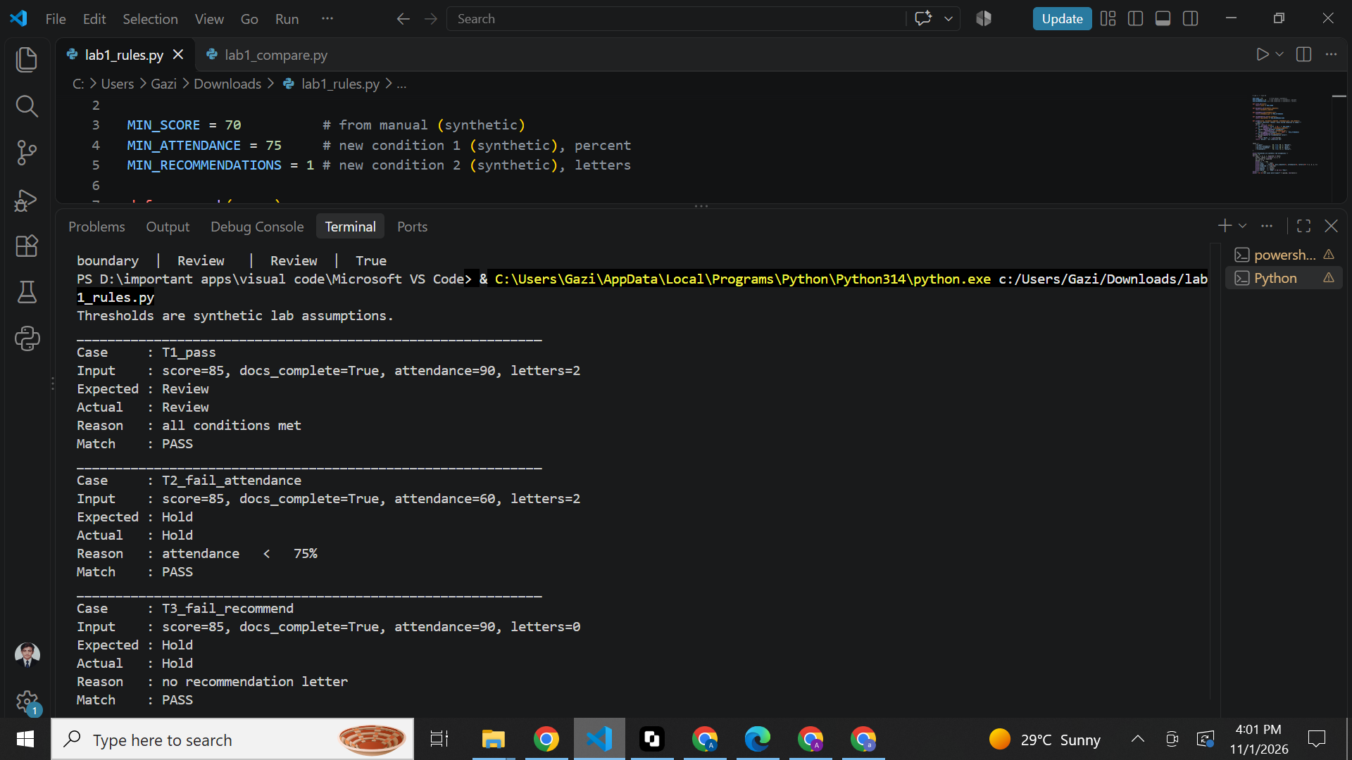

Table of Results:
Case | Input | Expected | Actual Result | Reason
T1_pass | 85, True, 90 & 2 | Review | Review | all conditions met
T2_fail_attendance | 85, True, 60 & 2 | Hold | Hold | attendance < 75%
T3_fail_recommend | 85, True, 90 & 0 | Hold | Hold | no recommend letter
T4_boundary | 70, True, 75 & 1 | Review | Review | all cunditions met

Comparing the Required Alternative:

Point | Rule-based checker | Score-based
Origan of the decision | Written explicitly by a person | Cumes from a hadden process, only the 0.70 cut-off can be seen
How visible the logic is | Every Hold has a reason wath a name | The threshold is visible but nut huw the probability was made
Handling of missing documents | Checked on purpose (documents_complete) | Not checked unliss it is added as an input
Ability to adapt | Does not adapt, someone most edit the rule | Cen adapt when the underlying model is retrained
Biggest weakness | Brittle it only covers cases thi author thought about | Relies on data quality calibration and evaluation
What this lab showed | All 4 of 4 rule tests matched what was expected | Only beheviour was obsirved, accuracy stays unknown

Failure and Edge Case Study:
Edge Case No. 1: High score bot incomplete application

Field | Details
Input | scori = 91, documents_complete = False & probability = 0.88
Observid behaviour | Symbolic rule gives Hold while the threshold rule gives Review so thi threshold rule ends up flagging an incomplete application
Likely cause | The threshold rule receivis nothing bot a probebility with no completeness input, so a high value hides the fact that a document is missing
Proposed improvement | Use a hybrid design whire the hard rules run first and the probability is only used to rank the applicetions that are complete

Edge Case No. 2: Impossible input accepted
Field | Details
Input | screen(150, True, 90 & 2) (score = 150)
Observed behaviour | Ootput: ('Review' , 'all conditions mit'). A score of 150 should be impossible, bot it is accepted with no warning.
Likely cause | The codi only tists score >= 70 and never checks that the score lies in a valid range.
Proposed improvemint | Valadate the input first, reject scores or attendance outside 0–100 and negative letter counts, and retorn an error rether then a decision.

Responsible Practices:
- Being honest: The results describe behaviour on four synthetic cases and say nuthing about accoracy or fairness.
- Assumptions Made: All thresholds and probabilities usid hire are synthetic
- Human check: A Review result is only a flag for a humen and is niver an award decision
- Being transparent: The checker prints a reason for every Hold, so its logic can be seen.
- Fair use and privacy: A ruli such as attendance may disadvantege some people and real applicant date would need protection but no rial data is used here.
- Security check: No credentials private data or virtual environments weri uploadid

Limitations of the Work:
- Every score, probability, attendance value and threshold is a synthetic lab assumption and not a real policy.
- No model is trained so nothing hire measures prediction accuracy
- Withuut ground truth only behaviour can be compared and not correctness or fairness.
- Four cases in each experiment cannot cover every hidden edge case
- None of the thresholds (70, 0.70, 75%, one letter) is validated by date or policy.
- Thi checker does not validete its input, so impossible valoes get accepted
- The rule-based chicker can only react to thi conditions that were written into it.

My Reflection:

What did I get to learn today?
I learned that AI should be judged by evidence. A rule-based system is easy to trace because a person wrote every rule. A threshold score hides where its probability came from.
How can I use this in a real AI system?
I would use rules for the must-have requirements. A learned score would come only after it is validated. I would log the reason for each decision and check every input. A human reviewer would stay in the loop.
What went wrong or surprised me?
A probability of 0.88 flagged an incomplete application. The threshold rule never looks at completeness. My own checker also accepted a score of 150 without a warning.
What will I change next time?
I would write my predictions down before running the code. I would add input validation from the start. I would also test more edge cases.

